Name: ________________________ Group: _____

Photojournalism Assignment 1
Answer the following questions on a separate piece of paper. Be sure to staple it to this page when you submit it. Make sure you write in complete sentences.
1-What is the subject of this photograph?

2-What issue is this photo dealing with?

3-Describe how the COMPOSITION (the use of light, camera angle, background, foreground, rule of thirds, exposure…) of this image forces you to pay attention and helps convey the issue.

4-How did this photograph impact you (how did it make you feel)? Why?

5-In your opinion, do you think the photograph is appropriate for the subject matter? Would a different photograph have been better to convey the message? Why or why not?
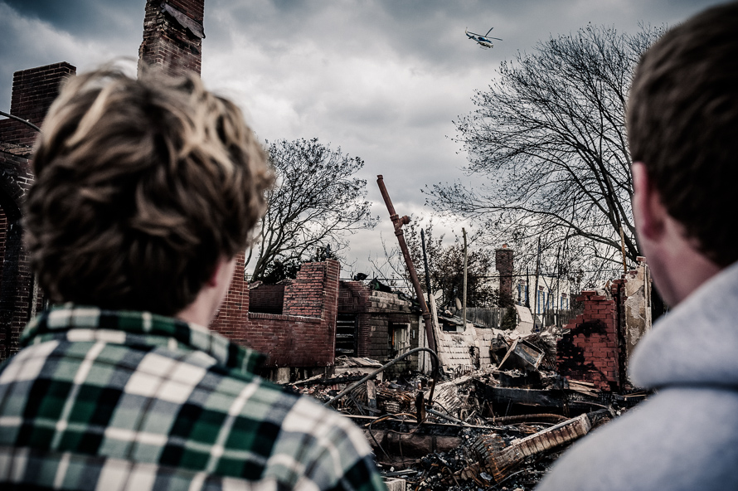
Caption: Cousins Tommy and Eddie Morgan watch as a helicopter passes over the charred remains of their best friend’s home after Hurricane Sandy . Both Tommy and Eddie were born and raised in Belle Harbor, NY.

